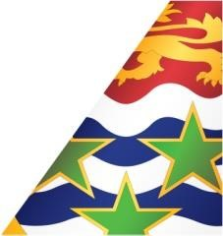
Media Contact:
Olivia Scott-Ramirez
Snr. Marketing & PR Manager
Email: oliviascottramirez@caymanairways.net

The La Ceiba flight schedule
Friday August 21, 2020
FLIGHT | FROM | TO | DEPARTS | ARRIVES
KX3880 | Grand Cayman | La Ceiba | 11:30am | 11:55am

Wednesday September 23, 2020
FLIGHT | FROM | TO | DEPARTS | ARRIVES
KX3880 | Grand Cayman | La Ceiba | 12:50pm | 1:15pm

The Kingston flight schedule
Wednesdays, September 2 & 30, 2020
FLIGHT | FROM | TO | DEPARTS | ARRIVES
KX3600 | Grand Cayman | Kingston | 10:00am | 11:05am

The Miami flight schedule
Tuesdays, September 1 & 22, 2020
FLIGHT | FROM | TO | DEPARTS | ARRIVES
KX3102 | Grand Cayman | Miami | 10:00am | 12:30pm

Note: Connecting flights from the Sister Islands may also be available for each flight.

